Changes & Modification wanted by EMT Client

Home Page
- About Company Section حول الشركة
  - Remove section text and place a YouTube video
  - https://www.youtube.com/watch?v=0CttfuXuOOE
- Add hovering social media buttons on the side of the site
  - 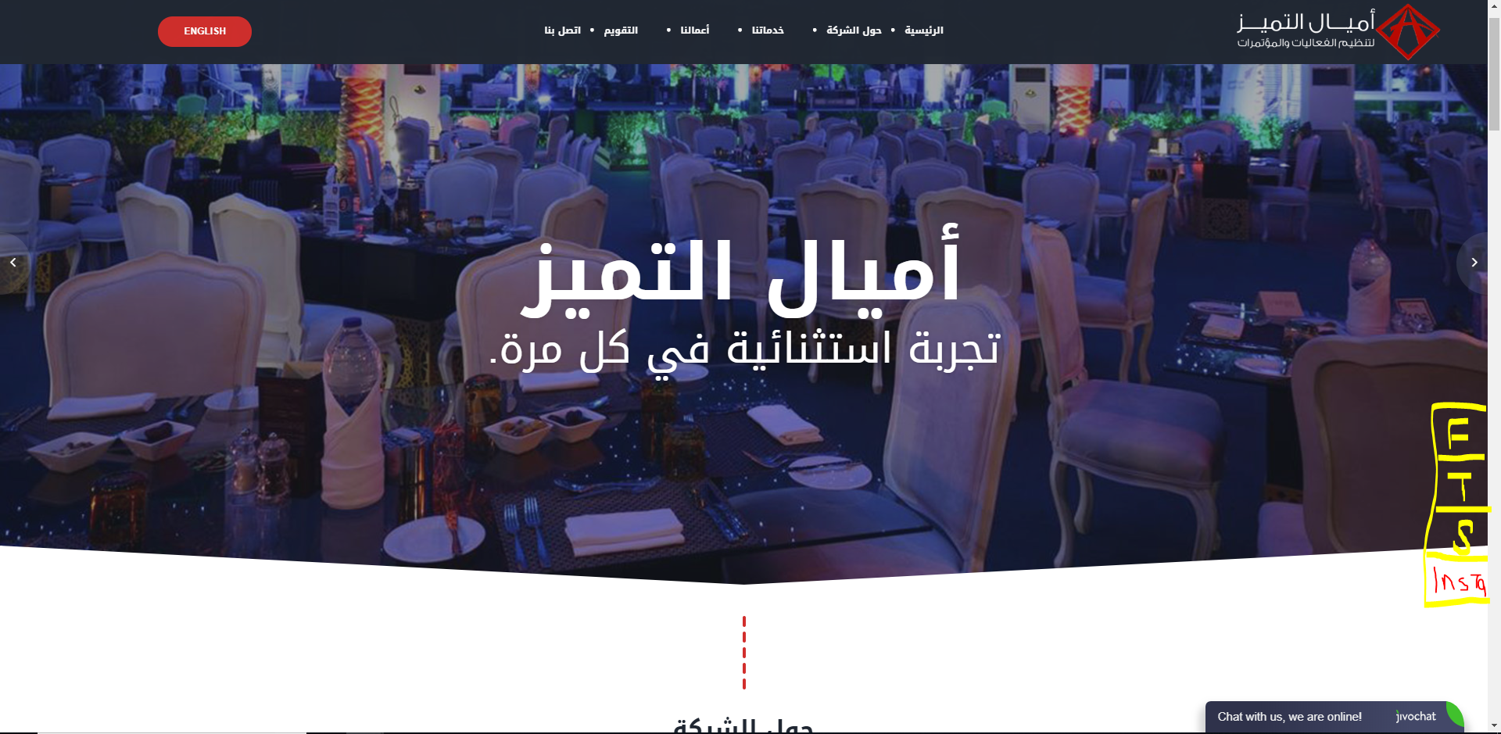
  - Or somewhere in the header next to the menu, which I don’t recommend
- Services Section
  - Show all services here and not some of them + the more button. When clicked website goes to the service details page
- Add our clients slider as a last section in the main page
  - Make our client slider auto rotate in both main page and about us page
- Footer
  - Add all the numbers in the footer. Currently it is only 1
  - 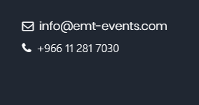

Contact Us Page
- Is it possible to add google maps under لزيارتنا Visit Us

Services Page
- Clients says the page is too white. Any suggestions form outside to make the page more colorful. For example alternating section colors OR adding a background logo

Our Works Page
- 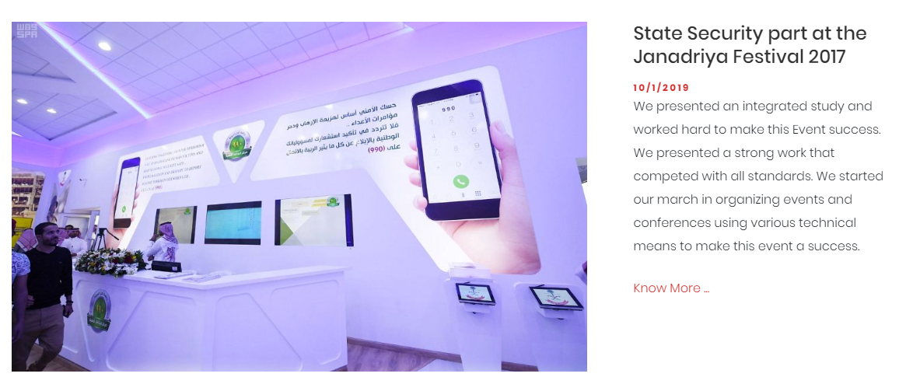
  - Is it possible to make the title bolder?
  - The date should be bigger
  - Is it possible in the summary to add a line break between the text?
    - The client want the content to be showing as follows:
<Title>
<Date>
<Service Type>
<Summary Text>
I was think we can tell him to write the service type with every summary as text and add a line break between it and the summary text

All Pages
- Remove the diamond shape form all the page headers and put the logo instead of it. Then I will show it to the client we might keep it and we might not. I recommended not to keep it
  - 
   